Stylecraft Special DK
Pastel Palette
 | >90 | 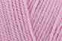 | Clematis
81 | 90 | 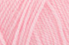 | Candy Floss
71 | 80 | 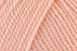 | Apricot
61 | 70 | 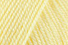 | Lemon
51 | 60 | 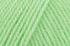 | Spring Green
41 | 50 | 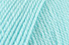 | Sherbet
31 | 40 | 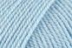 | Cloud Blue
20 | 30 | 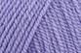 | Lavender
 | <20 | 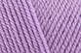 | Wisteria

